201532120106 李田原

ATM Class diagram

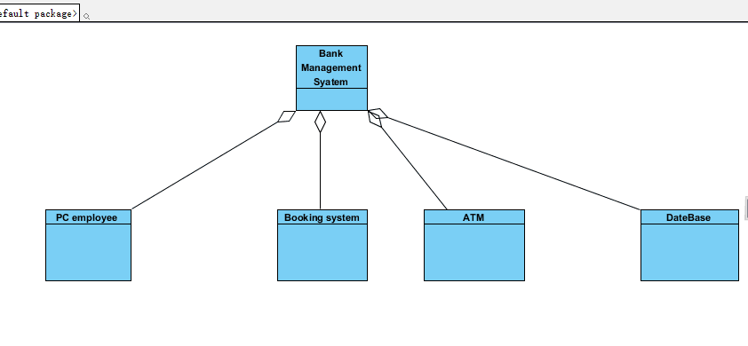

Collaboration Diagram

ATM Screen

6:import pin

9:choose things(withdraw money) 7:Verify pin

11:Input amount ($20) 12:withdraw $20

3:Screen initialization

5:Prompt input pin

8:Prompt selection

10:tip 13:check account $20

：Read the card number 14:deduct $20

1：insert the card

4:open accounts

The accounts

Card reader

15：offer $20

16:Provide a

Withdraw money machine

receipt